Neil Yetz

ERHS 532: Applied Logistic Regression

02/18/2016

Dr. Bachand

**ERHS 642 Logistic Regression Spring 2016**

**Homework Assignment 3 – New Version**

Similar to H-L chapter 3, page 87/88, exercise 2

1.

(i) Prepare a table showing the coding of the two design variables for RACE using

RACE=1, white, as the reference group’

Table 1.10: Design variables for race.

|  |  |  |
| --- | --- | --- |
|  | Design Variable 1 | Design Variable 2 |
| White | 0 | 0 |
| Black | 1 | 0 |
| Other | 0 | 1 |

(ii) Calculate the estimated ORs from the cross-classification of LOW by RACE

(Black vs. White, Other vs. White and Other vs. Black) by hand

Table 1.20: Cross Tabulation of Race by Low birth weight (LOW).

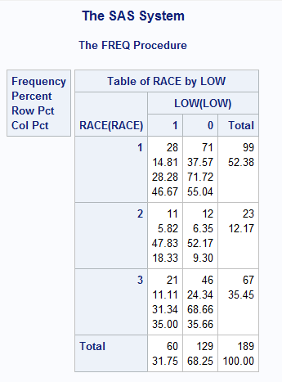

Race:

1= White

2=Black

3=Other

Table 1.21: Calculated OR’s for low birth weight outcome given Race as an exposure (Calculated using excel)

|  |  |
| --- | --- |
|  | OR |
| Black vs White | 2.324405 |
| Other vs White | 1.157609 |
| Other v Black | 0.498024 |

(iii) Calculate the 95% CIs for the ORs based on the formula

Table 1.30: Calculated Confidence limits for low birth weight given Race as an exposure (Calculated using excel).

|  |  |  |  |  |
| --- | --- | --- | --- | --- |
|  | OR | ln(OR) | Confidence Limits | |
| Black vs White | 2.324405 | 0.843464 | **0.922** | **5.878** |
| Other v White | 1.157609 | 0.146356 | **0.589** | **2.277** |
| Other v Black | 0.498024 | -0.69711 | **0.189** | **1.310** |

2.

(i) Using proc logistic, calculate the estimated ORs, 95% CIs and p-values for RACE

(Black vs. White, Other vs. White and Other vs. Black). Let SAS create the design

variables in proc logistic.

Table 2.10: SAS created Proc logistic Contrast estimate comparisons

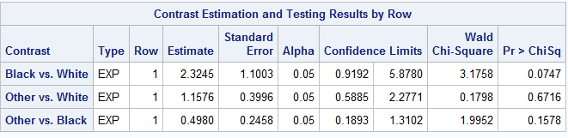

(ii) Using proc logistic, calculate the estimated ORs, 95% CIs and p-values for RACE

(Black vs. White, Other vs. White and Other vs. Black). Create your own design

variables in the data step and use them in proc logistic.

Table 2.20: Self-created Race model variables.

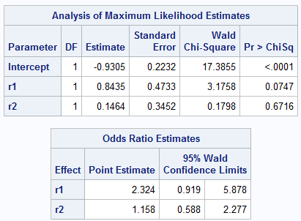

R1=Black

R2=Other

Table 2.21: Contrast Estimation table using self-created model variables.

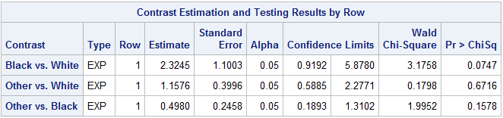

(iii) Compare the results in 2(i), 2(ii) and 1(ii) and (iii)

Looking at the results from all four of these I can see that they are all approximately equal. Everything was calculated the same regardless of how I coded or hand calculated it.

iv) Note that in this example some of the results are significant at the 10% but not 5%

level of significance. Explain circumstances under which you would choose to keep race in a statistical model and ones when you might not keep it.

I would choose to keep Race in my model if it was a main point in my hypothesis. For example, If I hypothesized race was one of my main risk factors to the outcome of Low birthweight, it would be critical to keep it in my model. Furthermore, if I find race was a confounder or an effect modifier to the outcome of low birth weight I would choose to keep it in my model.

If none of the above were factors in my decision, I would most likely choose to remove it from my model because it does not seem to be a significant predictor of low birth weight.

libname sdat 'C:\Users\ndyet_000\Desktop\Class Folders\Spring 2016\ERHS 642\Data';

/*data sdat.LOWBWT_altered; set LOWBWT_altered; run;*/

**data** LOWBWT_altered; set sdat.LOWBWT_altered;

*Question 2(ii);

if race=**1** then do; r1=**0**; r2=**0**; end;

else if race=**2** then do; r1=**1**; r2=**0**; end;

else if race=**3** then do; r1=**0**; r2=**1**; end;

**run**;

**proc** **print** data = LOWBWT_altered; **run**;

**Proc** **freq** data=LOWBWT_altered;

tables race;

**run**;

* Question 1 (i);

**proc** **sort** data=lowbwt_altered; by race descending low; **run**;

**proc** **freq** data=lowbwt_altered order=data;

tables race*low;

**run**;

* Question 2 (i);

**proc** **logistic** descending data=lowbwt_altered;

class race/param=ref ref=first;

model low=race;

contrast 'Black vs. White' race **1** **0**/estimate=exp;

contrast 'Other vs. White' race **0** **1**/estimate=exp;

contrast 'Other vs. Black' race -**1** **1**/estimate=exp;

**run**;

**proc** **logistic** descending data=lowbwt_altered;

model low=r1 r2;

contrast 'Black vs. White' r1 **1** r2 **0**/estimate=exp;

contrast 'Other vs. White' r1 **0** r2 **1**/estimate=exp;

contrast 'Other vs. Black' r1 -**1** r2 **1**/estimate=exp;

**run**;